100
Twoja odpowiedź:

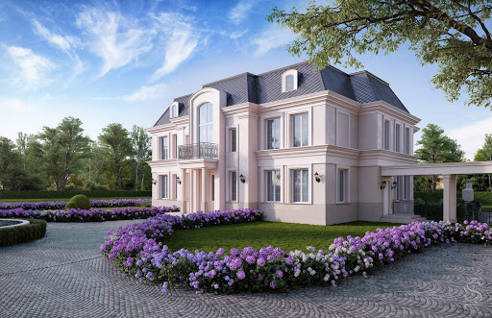 Willa
Twoja odpowiedź:

- Palczewska
Crossword on Warsaw.
Krzyżówka:
 |  | d
a |  |  | i
w |  | r |  | d
- A military conflict in a simple way. A noun.
- A very small insect that lives under the ground in a large and well-organized social groups.
- Get … of something. Po polsku – pozbywać się czegoś.
- The synonym of ‘important’, ‘serious’, ‘powerful’. Adjective.
- It is the world's second-largest and second-most populous continent, after Asia.
- What is the synonym of Earth.

- Palczewska
Nazwa tej dzielnicy pochodzi od słowa groch.
………………………
Dzielnica, której nazwa od słowa „biel” pochodzi.
……………………………………………….
Wielki ……………. Kultury i Nauki w Śródmieściu Warszawy.
Znasz o nim legendę. Był niebezpieczny, gdy patrzono mu w oczy. ………………………………………..
Dzielnica Warszawy, gdzie znajdziesz Zamek Królewski, Katedrę Jana Chrzciciela, Nowe Miasto oraz Barbakan. ………………………………

…………
Imię kobiety z mieczem nad brzegiem Wisły. ………….………………………..
Znajduje się tam pomnik Chopina. Ogród. ……………………………….
Pałac na …………. w aktualnej stolicy Polski.
A
W
W
A
A
Z
S
R

