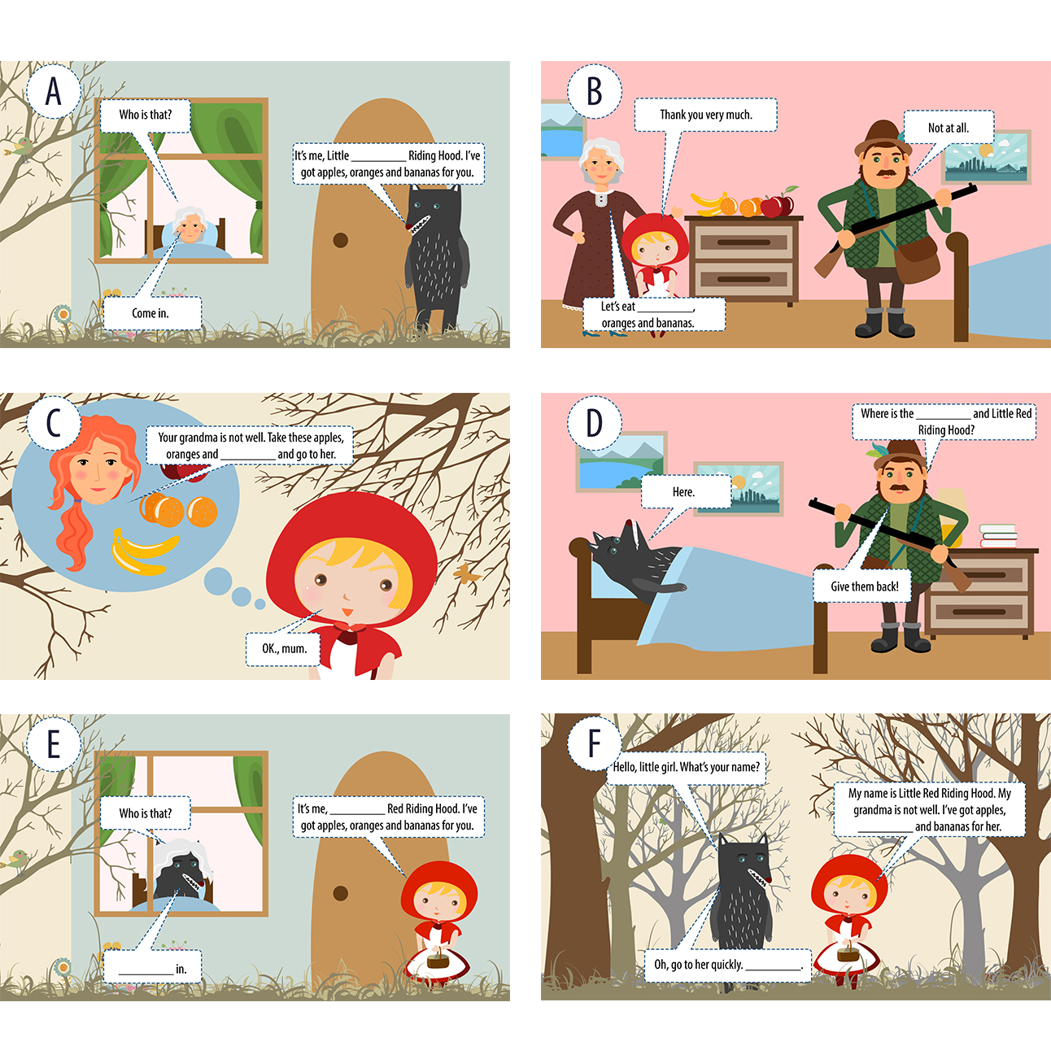

apples bananas Come Good-bye grandma Little Red oranges

